

**Lab No. 01**

Mehran University of Engineering and Technology Shaheed Zulfiquar Ali Bhutto Campus, Khairpur Mir’s Department of Software Engineering

**Course: Operating System SW-225 (Practical) - Instructor: Engr. Waqar Ahmed**

# Objective: Installation of Windows Operating System & BIOS Setup

|  |  |  |  |  |
| --- | --- | --- | --- | --- |
| **Name:** | **Mohammad Saleem** | **Roll Number:** | | **K20SW033** |
| **Score:** | **Signature:** | **Date:** | **09-08-2022** | |

|  |  |  |  |  |  |  |  |
| --- | --- | --- | --- | --- | --- | --- | --- |
| **LAB PERFORMANCE INDICATOR** | SUBJECT KNOWLEDGE | DATA ANALYSIS AND INTERPRETATION | ABILITY TO CONDUCT EXPERIMENT | PRESENTATION | CALCULATION AND CODING | OBSERVATION  /RESULTS | SCORE |
|  |  |  |  |  |  |  |  |

**Exercise/Tasks**

**Task:** Install Windows 10 in our system.

# Answer:

For Windows we need an bootable USB afetr that we will install Windows 10 in our system by following below steps.

# Step 01:

Start your system and press “F9” key to open “BIOS” and Enter your system password “8045”

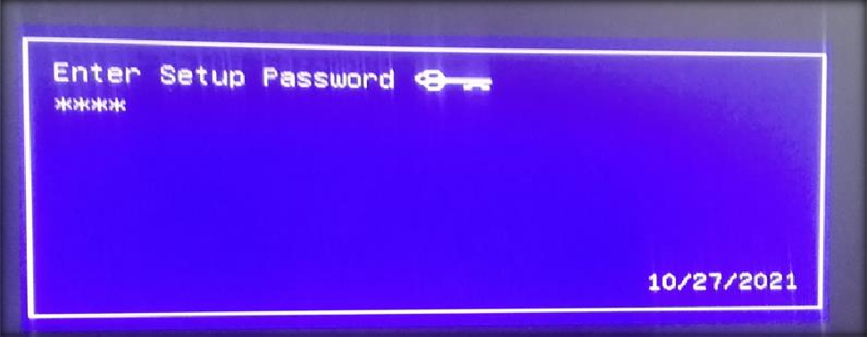

# Step 02:

Click on your bootable USB

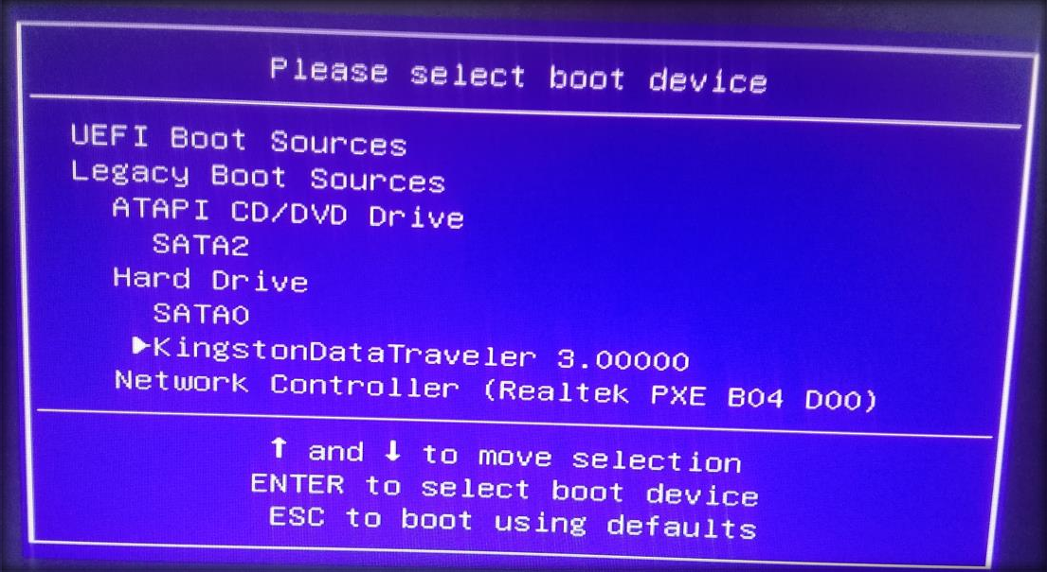

# Step 03:

Now set “Language, Time, Keyboard or Input method” and click on next

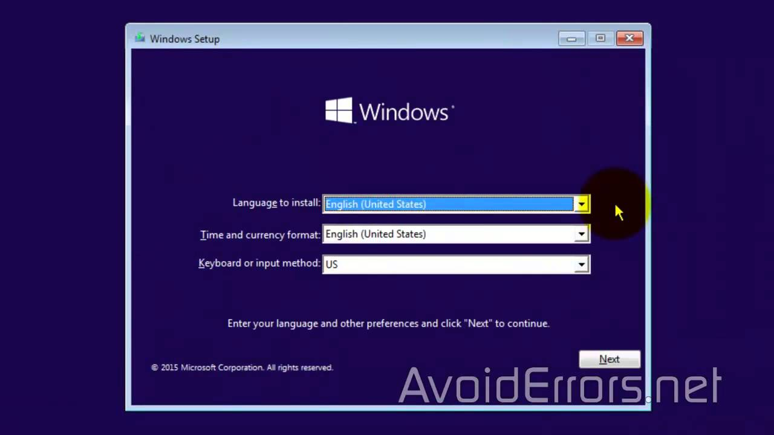

# Step 04:

Now Install Windows

# Step 05:

Now type Windows activator key if key is not available just click on next

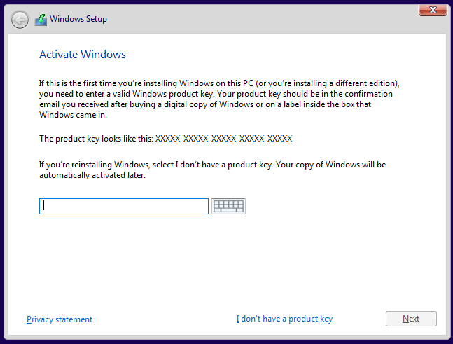

# Step 06:

Now select Windows 10 version you want to install

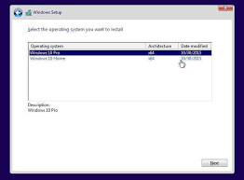

# Step 07:

Now accept license agreement and click on next

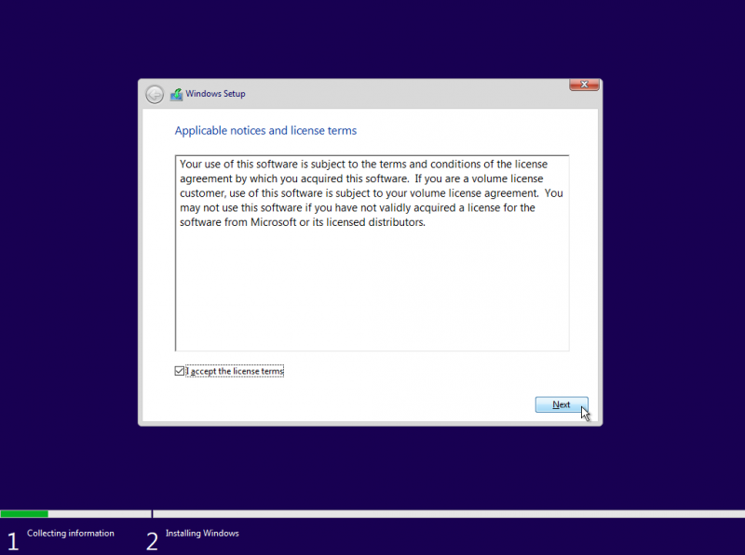

# Step 08:

Now click on custom installation

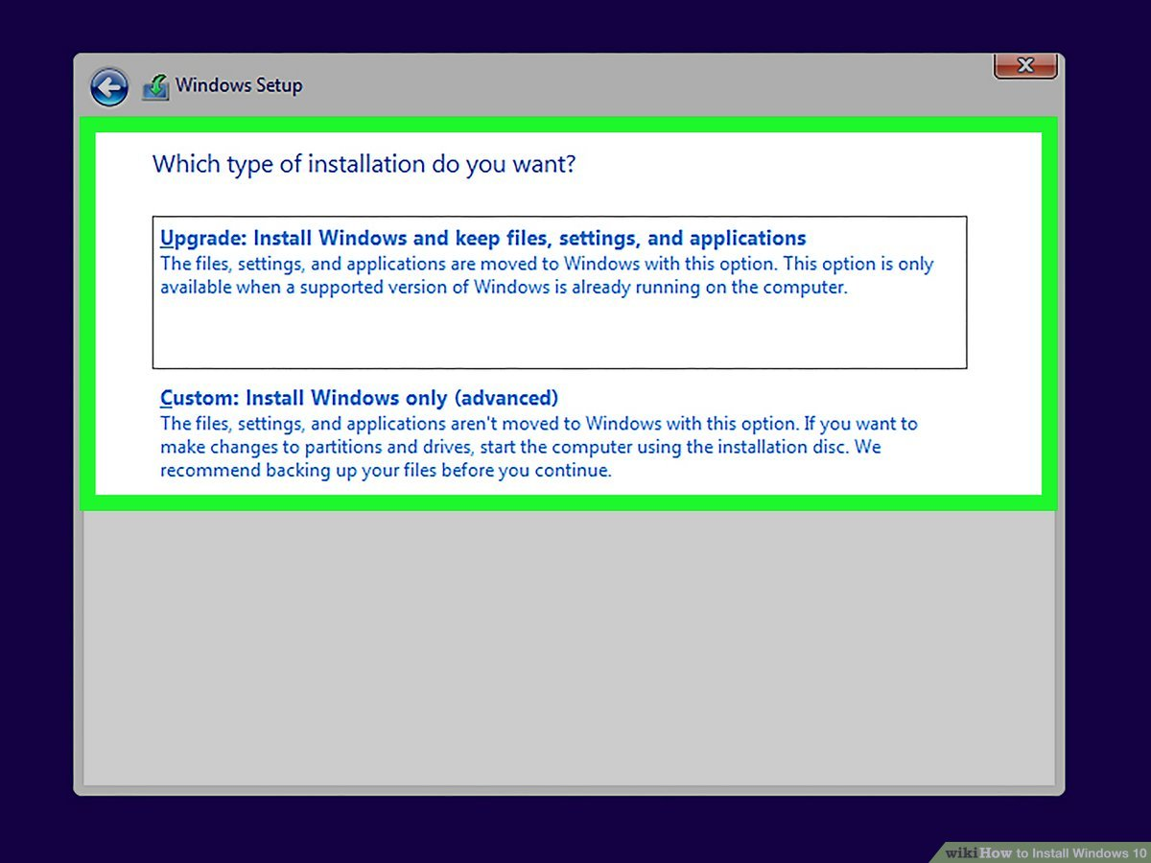

# Step 09:

Now make partitions of your Hard Disk but before that delete all partitions and make new partitions and click on apply

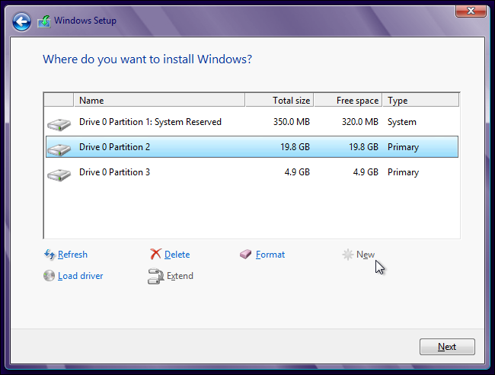

# Step 10:

Now the windows is getting started for installation accept all permissions and make settiengs according to your use.

# “On’t turn off your PC”

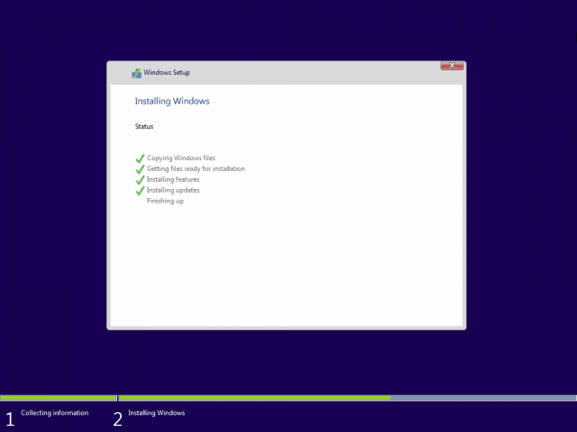

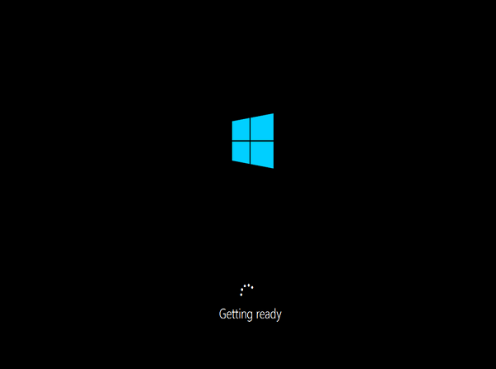

**Step 11:**

Click on accept

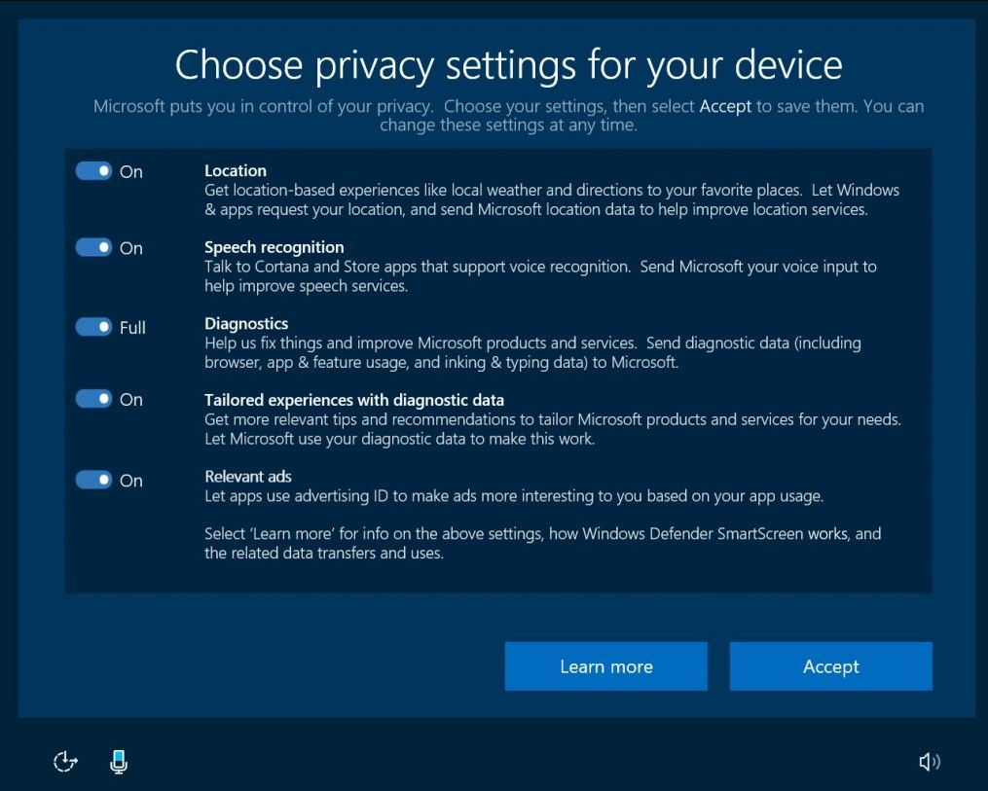

# Step 12:

Now windows is installed successfully

